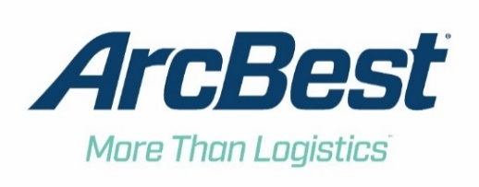
Investor Relations Contact: David Humphrey
Title: Vice President – Investor Relations
Phone: 479-785-6200
Email: dhumphrey@arcb.com

ArcBest Announces Its First Quarter 2022 Earnings Conference Call

FORT SMITH, Arkansas, April 4, 2022 — ArcBest® (Nasdaq: ARCB) will announce its first quarter 2022 financial results prior to the opening market on Friday, April 29, 2022. A conference call with company executives will be held that day at 9:30 a.m. EDT (8:30 a.m. CDT) to discuss these results. Interested parties are invited to listen by calling (800) 891-9945.

Following the call, a recorded playback will be available through the end of the day on June 15, 2022. To listen to the playback, dial (800) 633-8284 or (402) 977-9140 (for international callers). The conference ID for the playback is 22017045.

The call is being webcast and can be accessed live on ArcBest’s website at arcb.com. A replay of the webcast can be accessed at ArcBest’s website through June 15, 2022.

ABOUT ARCBEST
ArcBest® (Nasdaq: ARCB) is a multibillion-dollar integrated logistics company that helps keep the global supply chain moving. Founded in 1923 and now with over 14,000 employees across more than 250 campuses and service centers, the company is a logistics powerhouse, fueled by the simple notion of finding a way to get the job done. Through innovative thinking, agility and trust, ArcBest leverages their full suite of shipping and logistics solutions to meet customers’ critical needs, each and every day. For more information, visit arcb.com.
###

